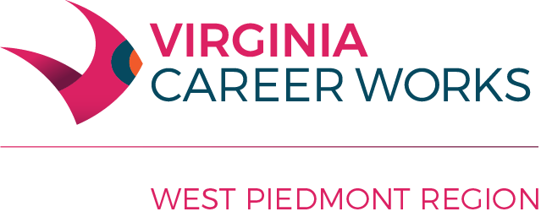
West Piedmont Workforce Development Board Meeting
Minutes
June 3, 2019

Present: Adam Wright, Corrie Bobe, Debra Buchanan, Donna Higdon, Guy Stanley, Julie Brown, Monica Mosley, Rebecca Adcock, Rhonda Hodges, R J Weaver, Robin Ferguson, Shannon Hair, Sharon Barksdale, Stacey Wright, Teresa Fontaine, Wayne Knox
Guests Present: Natalie Hodge (Ross), Lucius Chandler (VEC), Kimberly McIvor (VEC), Donna Martin (DARS)

Staff Present: Robert Bencini, Tyler Freeland, Robbin Hall, Robbie Knight, Lavinia Wingfield, Tiffany Macklin,
Jael Membreno
Adam Wright, Chairman, called the meeting to order at Martinsville One Stop Center, Martinsville, VA. Ms. R. Hodges called roll. Quorum was established with 16 in attendance. Mr. Wright welcomed all guests.
Mr. Wright asked the Board members to review the minutes attached for March 4, 2019. Ms. Brown made a motion to approve the minutes; Mr. Stanley seconded the motion; the motion passed unanimously.
Mr. Bencini explained to the Board members that financials are on target and are not overspent in any program. Mr. Wright suggested a summary of the financials going forward to lessen the number of pages of financial data for review. Mr. Bencini explained that progress is being made toward the new budget. Ms. Brown asked Mr. Bencini to summarize the budget thus far. He explained that with a decrease in the notice of obligation, we have taken a hard look at administrative expenses including decreasing costs in the fiscal agent agreement and Mallard and Mallard by the Controller taking on more tasks. Mr. Stanley asked about leases on space and Mr. Bencini stated that we are currently exploring options for moving both Danville and Martinsville Centers to reduce costs and align space with current needs. He explained that the current projection for the Ross budget is $1,083,755.29. Me. Bencini stated that with carryover funding, he would like to recommend a portion for Ross. Mr. Stanley made a motion to approve the financial report; Ms. Brown seconded; the motion carried unanimously.
Items on the consent agenda were discussed. Mr. Bencini summarized the Grants Application Policy to allow for grants to be submitted foregoing formal Board approval. Mr. Bencini summarized the grants in process. Ms. Brown asked for a description of the grants to be included. Mr. Hair asked about application status as well as volunteered to help. Ms. Brown volunteered to serve on a grants committee as well. Mr. Bencini gave a description of the new Board members. Mr. Wright explained the Bylaw revision. Mr. Weaver made a motion to approve the consent agenda; Ms. Wright seconded; the motion passed unanimously.
There was no old business.
Ms. Hodge with ross gave an update on the Rapid Response closeout that took place April 30, 2019. Area 17 received congratulations from the State on performance. We served 422 participants. Our Centers served over 22,000 visitors during the year. Our staff is more seasoned. Ms. Hodge shared some success stories.

Mr. Wright thanked all for attending. Mr. Bencini reported the new Committee Structure and informed all that committee meetings are being organized for the first quarter.

Mr. Stanley made a motion to adjourn; Ms. Buchanan seconded; the motion passed unanimously. The meeting adjourned at 4:45 p.m.

